Cross validation is a technique in machine learning used to avoid overfitting
HOW IT AVOIDS OVERFITTING
By splitting the data set into train and test, the model validation happens with some part of data. In train test split we will take first 800 records for train and last 200 for test out of 1000 records OR first 200 part for test and last 800 parts for train OR middle of the data part will be taken for test and other remaining parts for train.
The accuracy rate for all this different cross validations will be vary, all the varied accuracy will be summed to get average. This the process done in cross validation
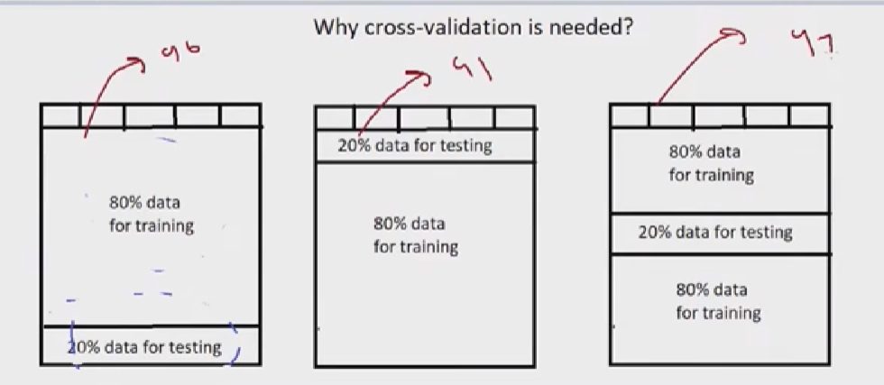
TYPES OF CROSS VALIDATIONS
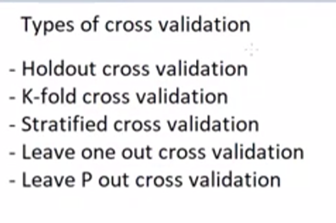
Holdout is splitting the data to 80,20 ratio.
In kfold all the red box will be the validation data. Validation error for each fold will be added to find the average
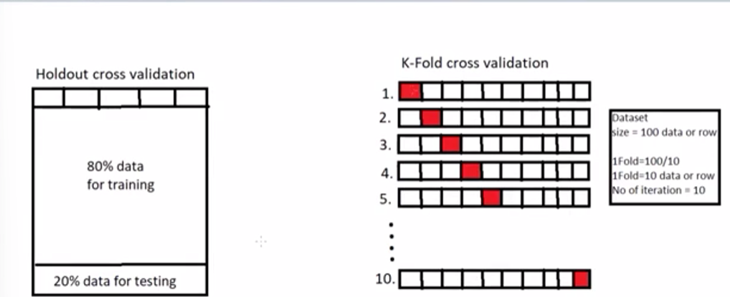
Stratified K Fold cross validation
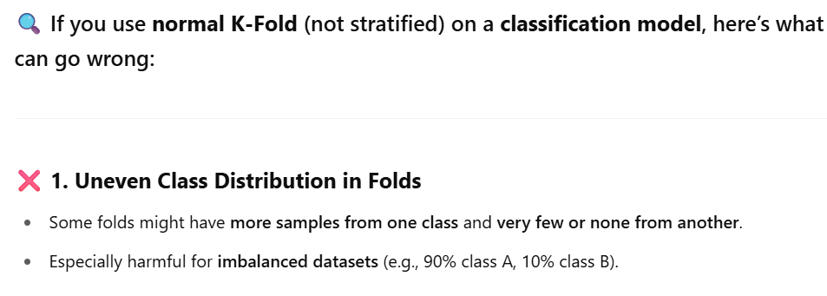
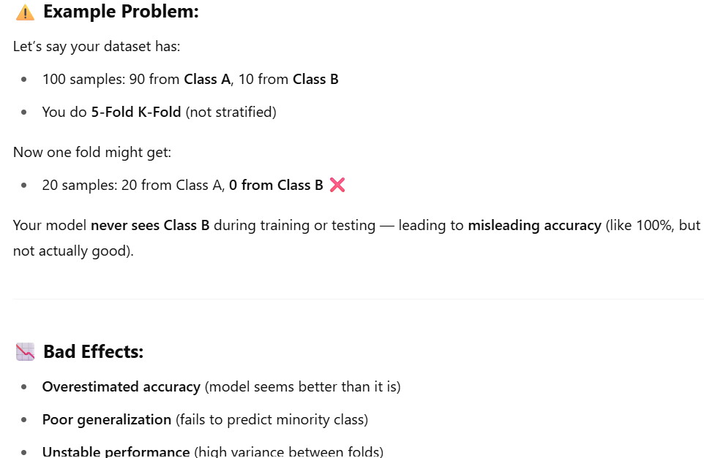
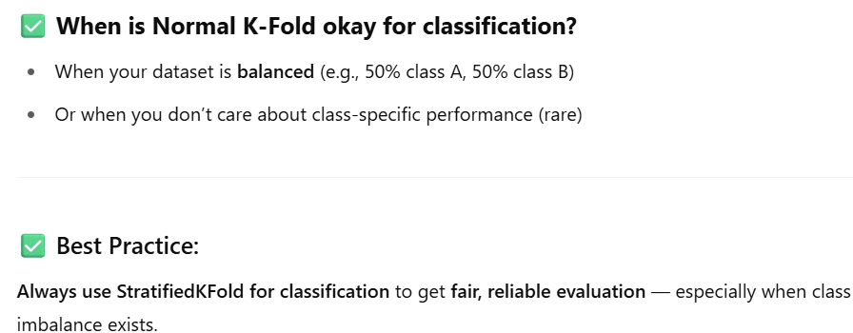

LEAVE ONE OUT CROSS VALIDATION
Here we will take only 1% data for testing for each fold, rest of the 90% data used for train. If we have 100 rows for data the iteration of this k-fold validation will be 100, on each iteration it takes only on data for test, So in first iteration only the first row will be used for test, and second iteration second row will be used for test and so on.
Note: Most of the time it is not used because it becomes overfitting to model
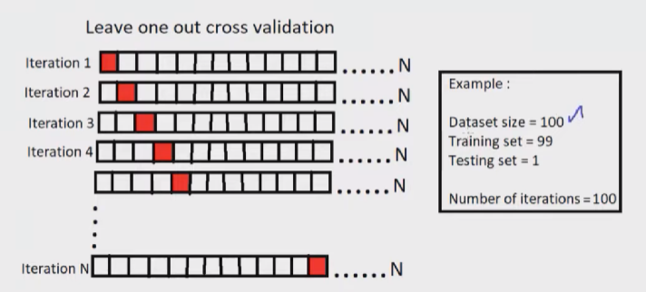

LEAVE P OUT CROSS VALIDATIONS
It is like leave one out but instead of taking one data for testing it take P number of data for testing, if the p is 3 then it will take only 3 row for each iteration fold.
